Experiment 3 – Spectrum Bands, Path Loss and Interference
Aim
To compare free-space path loss at sub-1 GHz, mid-band and mmWave frequencies, and examine how distance and frequency reuse affect estimated received power and SIR.
Procedure
- Run the MATLAB script.
- Record the estimated path loss and received power at 0.5 km for 0.7, 3.5 and 28 GHz.
- Inspect the path-loss and received-power plots.
- Compare the estimated SIR for reuse-cluster sizes 1, 3, 7 and 12.
- Change distance, transmit power or reuse size and rerun.
MATLAB PROGRAM
clear; clc; close all;
freqGHz = [0.7 3.5 28];
freqMHz = freqGHz*1000;
band = ["Sub-1 GHz";"Mid-band";"mmWave"];
Pt = 30; Gt = 0; Gr = 0;
d = logspace(log10(0.1),log10(2),200);
d0 = 0.5;
fspl = @(f,dist) 32.44 + 20*log10(f) + 20*log10(dist);

loss0 = fspl(freqMHz,d0);
rx0 = Pt+Gt+Gr-loss0;
disp(table(band,freqGHz',loss0',rx0', ...
'VariableNames',{'Band','GHz','FSPL_dB','RxPower_dBm'}));

figure; hold on; grid on;
for k=1:length(freqMHz), plot(d,fspl(freqMHz(k),d),'LineWidth',1.5); end
set(gca,'XScale','log'); xlabel('Distance (km)'); ylabel('Path loss (dB)');
legend(band); title('Free-Space Path Loss');

figure; hold on; grid on;
for k=1:length(freqMHz), plot(d,Pt-fspl(freqMHz(k),d),'LineWidth',1.5); end
set(gca,'XScale','log'); xlabel('Distance (km)'); ylabel('Rx power (dBm)');
legend(band); title('Estimated Received Power');

R = 0.5; N = [1 3 7 12]; n = 3.5;
D = sqrt(3*N)*R;
SIRdB = 10*log10((D/R).^n/6);
disp(table(N',D',SIRdB','VariableNames',{'ReuseN','InterfererDistance_km','SIR_dB'}));
figure; plot(N,SIRdB,'o-'); grid on;
xlabel('Reuse cluster size N'); ylabel('Approximate SIR (dB)');
title('SIR versus Reuse Cluster Size');

OUTPUT
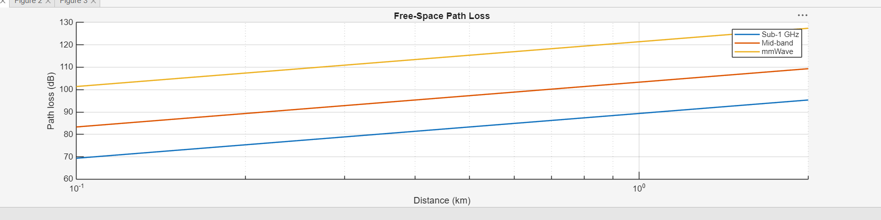

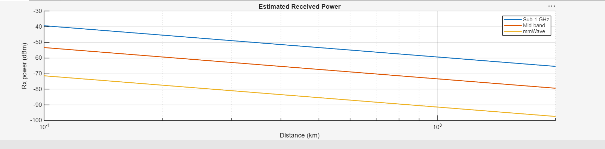

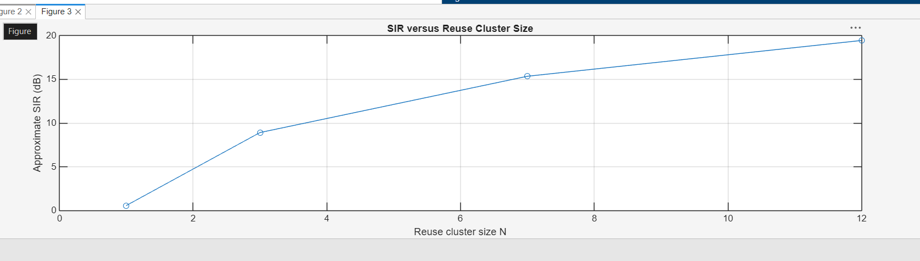

Result
The model shows higher free-space loss at higher frequency for the same distance, and lower received power as distance increases. The simplified SIR increases with reuse-cluster size. These are idealized estimates, not actual coverage predictions.

